Insurance Agents E&O

Many persons and organizations in the insurance industry are subject to claims involving professional negligence. The acts of insurance agents, insurance companies, insurance consultants, safety engineers, actuaries (and others) can give rise to allegations that their services have caused economic loss. Section XV analyzes both the professional liability exposures of these persons and entities as well as the types of insurance coverage required to address those exposures.

Traditionally, the difference between insurance agents and brokers is that agents are considered representatives of insurance companies while brokers are thought of legally as representatives of insureds. Despite such terminology, the distinctions between the legal duties owed by agents and brokers have, in recent years, become blurred for several reasons. First, the results of court cases have clearly indicated that agents owe duties to insureds despite the lack of a traditional agency relationship. Similarly, case outcomes have also held that brokers owe certain duties to insurers despite the lack of a traditional agency relationship. Second, the same organization or individual can act as both a broker and an agent in the same transaction. (The doctrine of "dual agency" is well recognized by case law in several jurisdictions, including California.)
The legal duties required of insurance agents determine their potential liability to insureds. Insurance agents owe their insureds a number of duties that, if breached, could give rise to professional liability claims.
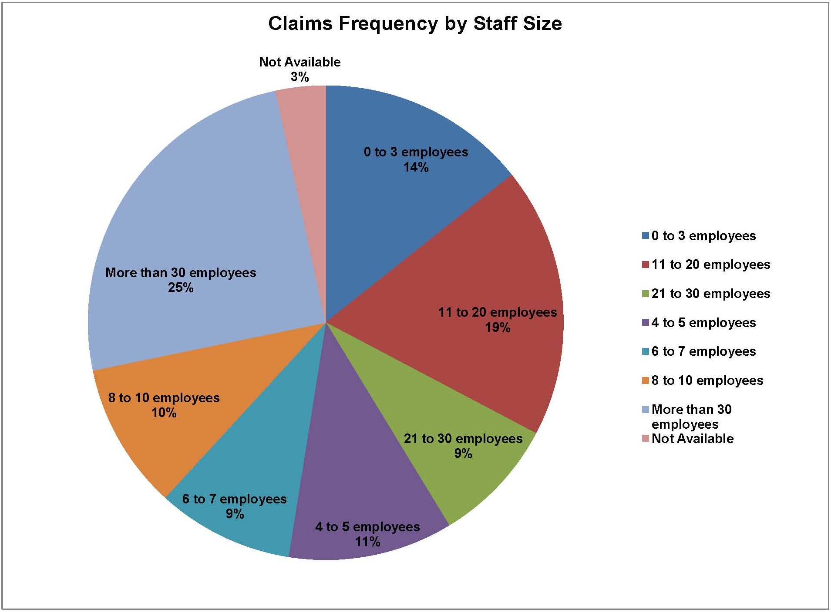

Duty To Procure Coverage
An agent undertaking to procure insurance for a customer owes an obligation to the insured, which courts have defined as either (a) a contractual obligation, i.e., to strictly perform according to the contract or be liable for failure to perform, see Lazzara v. Howard A. Esser, Inc., 802 F.2d 260 (7th Cir. 1986); or (b) as a negligence duty, i.e., an obligation to use reasonable care. See Fioventino v. Travelers Ins. Co., 448 F. Supp. 1364 (E.D. Pa. 1978) (court held that an insured may bring a claim for negligent misrepresentation where an agent told the insured that he was covered, when, in fact, the agent failed to procure coverage). These two concepts often are merged or commingled by the courts, which occasionally refer to "negligent breach of contract," and often observe that legal theories of negligence and breach of contract overlap in describing an agent's or broker's duties. See Huff v. Harbaugh, 435 A.2d 108 (Md. App. 1981).
The threshold issue in determining whether an agent breached its duty to obtain coverage is whether an agent undertook an obligation to procure the coverage. Courts have examined the extent to which an agent and consumer must agree as to some or all elements of the coverage before the agent has the duty to obtain the coverage. Case law indicates that a meeting of the minds is not required between the agent and consumers respecting all material aspects of the coverage. For example, in Harrell v. Davenport, 299 S.E.2d 308 (N.C. Ct. App. 1983), the insured sought property coverage for two tractors. The broker admitted that he advised the plaintiff that he would procure the coverage but was too busy and failed to do so. The court held that, although the agent and consumer had not discussed the policy period or the amount of the premium, it was enough that the agent and the customer discussed the identity of the property and the value of the property being insured to send the case to a jury. The court ruled that it would be a question of fact for the jury to determine whether the broker had undertaken to obtain the policy. The court then ruled that if the jury determined that there had been such an undertaking, it also would be necessary for the jury to determine whether the agent used reasonable diligence in attempting to procure the insurance policy.
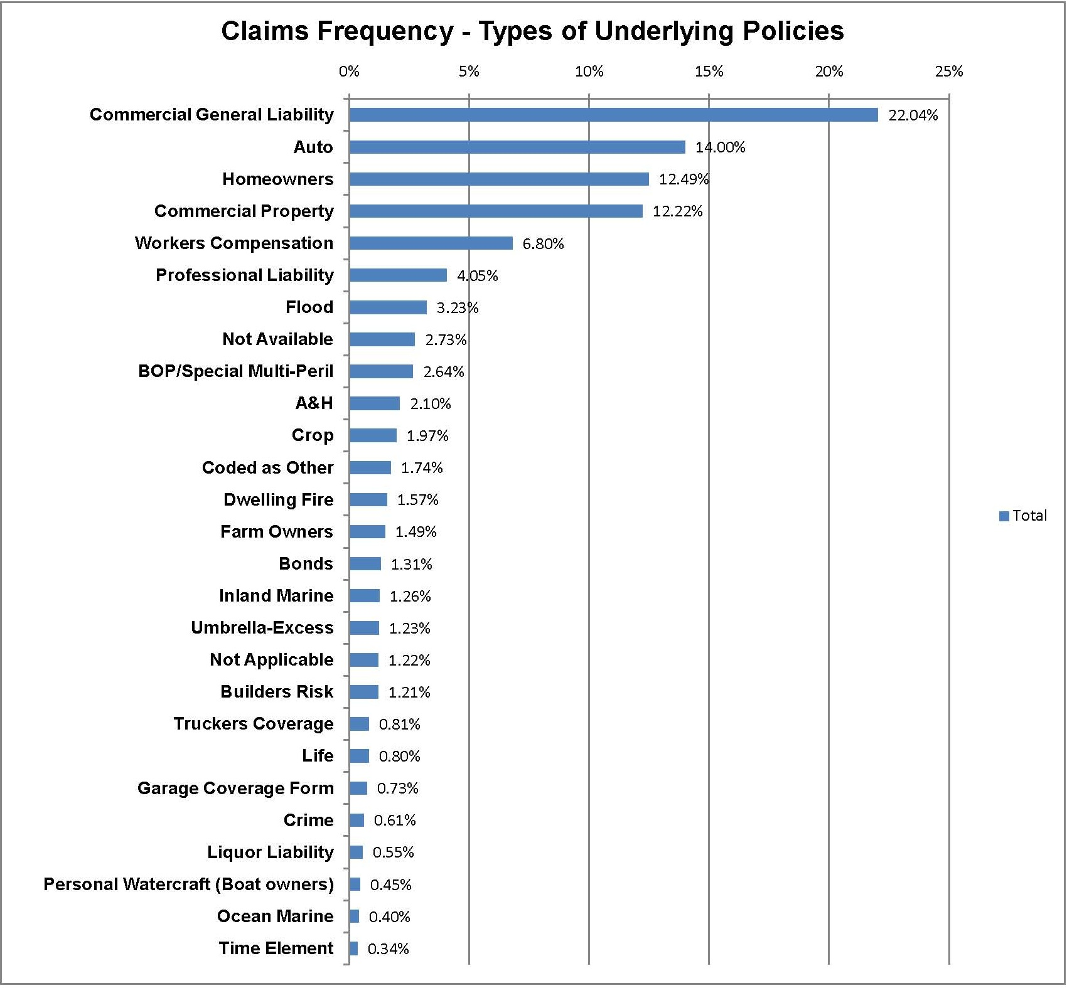
Conversely, a broker cannot be held liable for failing to procure insurance if it is shown that the broker never undertook that obligation. See, e.g.,Willis Ins. Agency Inc. v. Luckey, 466 So. 2d 1197 (Fla. Dist. Ct. App. 1985); and Gabrielson v. Warnemunde, 443 N.W.2d 540 (Minn. 1989).
In contrast to Harrell, other courts have found a broker liable for not strictly complying with the client's instructions, regardless of the broker's motives, intentions, or conduct. For example, in Cassidy v. Dauch, 145 N.Y.S.2d 485 (N.Y. Sp. Term 1955), and Progress Laundry Co. v. Schweik, 75 N.E.2d 390 (Ill. App. Ct. 1947), the courts held that a broker's duty was not merely one to obtain an insurance policy but to obtain the precise policy that conformed to the application. An application form is the clearest and best way to establish the presence or absence of an undertaking and the precise scope of the undertaking. The cases are legion in which the insureds claim after a particular loss that they orally had asked the broker to obtain "complete coverage" or "whatever insurance was needed." The best way for a broker to protect himself or herself from these kinds of claims is to document the undertaking through an application completed and signed by the client—preferably an application presenting various options requiring the insured to select the particular desired coverage option.
A "reasonable diligence" standard of care also applies to a broker's promptness in procuring insurance. See Arthur Glick Truck Sales Inc. v. Spachaccia Ryan Has Inc., 290 A.D.2d 780 (N.Y. 2002). Thus, a Florida court held that an insurance agency was not liable for failing to procure a policy before an accident occurred, where the evidence indicated the agency had exercised reasonable diligence in attempting to procure the policy in a timely manner ( Auto-Owners Ins. Co. v. Brockman, 524 So. 2d 490 (Fla. Dist. App. Ct. 1988)). A fundamental rule established by the courts provides that an agent who undertakes to procure insurance has a duty to obtain the insurance in a timely manner, or properly notify the client if unable to do so. This rule was initially articulated by the New York Court of Appeals in Barile v. Wright, 256 N.Y. 1 (N.Y. 1931).

Prima Facia Case for Failing To Procure Insurance
In an action against an agent for failing to procure insurance coverage, the plaintiff must prove three things. First, the plaintiff must show that the agent had a duty to exercise reasonable care and diligence to procure insurance coverage. See Weinlood v. Fisher & Associates, Inc., 975 P.2d 1226 (Kan. App. 1999). Second, he or she must show that the agent breached this duty. See Dimarino v. Wishkin, 479 A.2d 444 (N.J. Super. 1984). Finally, the plaintiff must show causation. See Port Clyde Foods, Inc. v. Holiday Syrups, Inc., 563 F. Supp. 893 (S.D.N.Y. 1982).

Factors Establishing the Duty To Procure Coverage
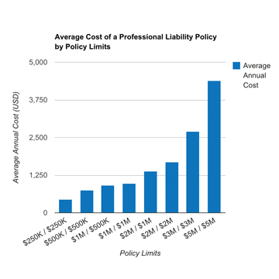
Several factors must be present to support an insurance agent's liability to the insured for failing to procure coverage. First, the agent must undertake to obtain insurance for a client. Second, there must be an understanding of the client's principal coverage requirements. Third, the coverage sought by the client must be reasonably available. An agent is not an insurer and is not liable simply because the coverage is unavailable. An agent may fulfill his or her duty to a client by making a reasonably diligent effort to obtain the policy. If the agent makes that effort and promptly notifies the client of the unavailability of coverage, the agent should not be exposed to liability. However, where the agent fails to make a diligent effort to obtain the policy and/or does not inform the client of the unavailability of coverage, the agent may be liable for failing to procure insurance (see Haggans v. State Farm Fire & Casualty Ins. Co., 803 So. 2d 1249 (Miss. Ct. App. 2002) and Wheaton National Bank v. Dudek, 376 N.E.2d 633 (Ill. App. Ct. 1978)).
Courts often refer to coverage availability in terms of a causation requirement, requiring the client to prove that the alleged error or breach of contract by the agent or broker caused the cited injury. The majority of courts addressing the issue have declined to impose liability where the plaintiff was either uninsurable or the desired coverage was unavailable in the marketplace. See Kinns v. Shulz, 516 N.Y.S.2d 817 (N.Y. App. Div. 1987). In Melin v. Johnson, 387 N.W.2d 230 (Minn. Ct. App. 1986), the court reversed a plaintiff's verdict because the trial court failed to instruct the jury that it had to find that the requested insurance was in fact available.
However, some courts have rejected this majority rule and have held that the broker may be liable for failing to procure insurance even though there was no showing that the insurance was obtainable. For example, in Bell v. O'Leary, 744 F.2d 1370 (8th Cir. 1984), the Eighth Circuit Court of Appeals rejected the broker's defense that he could not be held liable because the insurance was not available. The court reasoned that the broker had failed to inform the plaintiffs of his inability to obtain the insurance, and thereby had lulled them into the belief that their losses would be covered.
Courts dealing with coverage for pollution liability losses have, on occasion, found polluters to be uninsurable because they knew about or reasonably could have expected the resulting losses, and therefore lacked fortuity to be insured, or they were a loss in progress. In those cases, claims against brokers have often become moot because courts have determined that the claimants were not insurable risks.

Liability for Failure To Procure All of the Coverages Required
An agent may also be found liable for failing to procure a policy that offers all the coverages sought by the customer. For example, in Trahan v. Bailey's Equip. Rentals, Inc., 383 So. 2d 1072 (La. Ct. App. 1980), the agent obtained a commercial automobile liability policy for a consumer. The policy contained an endorsement that excluded the use of vehicles further than 50 miles from the consumer's place of business. The agent overlooked that the policy contained the limiting endorsement and the evidence proved that the consumer was assured by the agent that he was fully covered regardless of where an accident occurred. An accident occurred involving one of the consumer's vehicles more than 50 miles from the consumer's place of business. The insurer successfully denied coverage. The insurance agent was found liable for the insured loss suffered by the consumer because he failed to advise the consumer of the existence of the limiting endorsement. The moral of Trahan is that a broker should be circumspect when describing the coverage that has been obtained. The broker should remind the client that the coverage is subject to all of the terms, conditions, and limitations of the policy and encourage the insured to read the policy.
In contrast with the Trahan case, courts frequently have refused to hold brokers liable for errors in situations where the insureds were knowledgeable in business affairs and insurance. This is often referred to as the sophisticated insured factor. For example, in Brokers Title Co. v. St. Paul Fire & Marine Ins. Co., 610 F.2d 174 (3d Cir. 1979), the court held that the plaintiff, a title insurance company, and its officers were knowledgeable about the insurance industry and therefore could not claim that their broker had failed to explain the meaning of a standard policy exclusion. Other courts have rejected this defense, while some courts do not even recognize this defense altogether. For example, inMitchell v. N.C. Grange Mut. Ins. Co., 268 S.E.2d 254 (N.C. Ct. App. 1980), the court held that a broker could not avoid liability for failing to provide requested coverage simply because the client was a sophisticated insured.

Duty To Advise If Coverage Is Unavailable
In the event that insurance is unavailable, an agent may discharge his duty to the consumer by giving prompt notification of his inability to place the risk. The court in SHRV Teletype Coin Exch. v. Commercial Union Ins. Co., 191 So. 2d 208 (La. Ct. App. 1966), affirmed a judgment for the agent, concluding that the evidence supported the finding that the agent made reasonable efforts to procure the insurance and gave prompt notification of his inability to meet the customer's requirement.

Consequential Damages from Failure To Procure Coverage
While it is axiomatic that consequential damages may be recoverable in an action against an agent for failing to procure coverage, there is an issue as to the scope of those damages. Some courts have limited recovery to the amount that the client would have received as benefits if the requested coverage had been obtained. See Century Boat Co. v. Midland Insurance Co., 604 F. Supp. 472 (W.D. Mich. 1985). A client who must bring an action for an agent's failure to obtain coverage will often experience a significant delay in obtaining the benefits sued on. Courts have, therefore, awarded plaintiffs consequential damages based on losses incurred by the plaintiff because of this delay. See Topmiller v. Cain, 657 P.2d 638 (N.M. Ct. App. 1983). Lost profits, loss of equity, and other business losses also may result in a damages award.
In Riedman Agency, Inc. v. Meaott Constr. Corp., 456 N.Y.S.2d 553 (N.Y. App. Div. 1982), the consumer was a construction contractor that required certain payment and performance bonds to bid for a contract. The agency assured the customer that the required bonds would be issued, and the contractor entered the low bid for the project. The requested insurance coverage was not provided by the insurer, and the contractor lost the engagement for that reason. The agent then failed to notify the customer of its inability to obtain the payment and performance bonds. In fact, the agent assured the customer the bonds would be issued as late as 1 day before the contractor was advised its bid was rejected because of its failure to obtain the insurance. The contractor asserted damages against the agency in the amount of $525,000 and claimed lost profits due to the agent's failure to secure the construction contract. Riedman demonstrated the significance of consequential damages that may result from a failure to procure insurance, where damages may not be limited to those arising from the absence of coverage for a loss.

Insured's Duty To Transmit Information to the Insurer
Generally, courts are quite tough on insureds who seek to benefit from applications containing material misrepresentations, even where the insureds claim that the broker was at fault. When a physician concealed material facts about his medical history on an insurance application, he could not recover against his agent or insurer when the policy was later rescinded (see Suriano v. Equitable Assurance Soc'y, 566 N.Y.S.2d 623 (N.Y. App. Div. 1991)). This is perhaps an obvious case, but this rule has been upheld even in more subtle circumstances. For example, an agent was not liable for failing to procure a life insurance policy where the proposed insured was a well-known athlete who abused cocaine, for whom no insurer would have issued a multimillion-dollar policy (see Bias v. Advantage Int'l, Inc., 905 F.2d 1558 (D.C. Cir. 1990)). In Bush v. Mayerstein-Burnell Financial Services, Inc., 499 N.E.2d 755 (Ind. Ct. App. 1986), an insurer denied coverage for hospitalization of an insured because the applicant had failed to disclose that he had other insurance coverage. The court held that the agent was not liable for the nondisclosure, because the cause of the denial of coverage was the plaintiff's failure to give the agent correct information.

Agent's Duty To Review a Customer's Insurance Needs
An agent's duty is not limited, however, simply to fulfilling a customer's order. An agent may also have a duty to review a customer's needs and to advise the customer of available coverages beyond what the customer has requested. The degree to which a client relies on the agent's professional expertise may also affect the standard of care. In Dimeo v. Burns, Brooks & McNeil, Inc., 504 A.2d 557 (Conn. App. Ct. 1986), the jury was instructed that the standard of care owed by the agent was the "knowledge, skill and diligence of insurance agents" in handling similar cases during the same period and in the same general area. The court reasoned that selling insurance is a "specialized field with specialized knowledge and experience." The court further stated that the insured "ordinarily looks to his agent and relies on the agent's expertise in placing his insurance problems in the agent's hands." As with doctors and lawyers, an insurance agent is a professional who holds himself out as an expert in a particular field.
The nature and scope of this duty again originates from the engagement or undertaking by the broker. If the undertaking is merely to procure insurance as requested, courts often find there is no duty to provide advice. The likelihood of a court finding a duty to advise a client often depends on the overall facts of the relationship. If the client approaches an agent only to obtain a special type of insurance, it is unlikely the court will impute a generalized duty to advise. As discussed above, if the consumer is a sophisticated insured with its own staff of insurance professionals, it is less likely that a duty to advise will be imputed to the broker. However, if the client is not sophisticated, the relationship has continued for a period of time, and the insured is not shopping around, then a court is more likely to find greater duties to advise the client as to its insurance needs. The courts, therefore, look to whether special circumstances exist that create heightened duties. A broker will be held liable for failing to give an insured adequate advice when he or she holds himself or herself out to the insured as a skilled insurance adviser. Hardt v. Brink, 192 F. Supp. 879 (W.D. Wash. 1961). This determination is typically analyzed on a case-by-case basis. Aetna Casualty and Surety Co. v. Walter Ogus, Inc., 396 F.2d 667 (D.C. Cir. 1968). See also United Farm Bureau Mutual Ins. Co. v. Cook, 463 N.E.2d 522 (Ind. App. 1984) (agent had duty to advise where relationship of trust had developed over a 10-year period, agent admitted he had counseled client as to what coverage was available for client's farm, and agent had exercised broad discretion in meeting client's needs).
Special circumstances have generally been shown in four types of situations: (1) The agent receives fees or payments beyond commissions generated from the payment of premiums; (2) the insured makes a clear request for advice; (3) there is an extended course of dealing that would put a reasonable agent on notice that his or her advice is being sought and relied upon or reasonably expected; and (4) the agent becomes aware of special information that creates a duty to advise the insured.
For example, in Bell v. O'Leary, 577 F. Supp. 1361 (E.D. Mo. 1983), a special duty to advise was invoked where an insurance broker undertook to provide flood insurance on two mobile homes, but failed to advise the clients that the mobile homes were located in an area not approved for coverage under the National Flood Insurance Program and, thus, that flood insurance was not available. The court found the agent liable because his failure to advise the clients prevented them from remedying the situation by moving their mobile homes. In another case, an agent negligently advised a farmer that he was not eligible for federal crop insurance when in fact the farmer was eligible. The farmer subsequently suffered a crop failure having not made any other efforts to obtain the coverage. The court held that the agent had no obligation to provide insurance nor to advise the farmer. However, once the agent undertook to respond to the inquiry and did advise the client, he assumed a duty to exercise reasonable care. (See Aesoph v. Kuser, 498 N.W.2d 654 (S.D. 1993).) In contrast, another court held that an agent's statement to a convenience store owner that he had "what he needed" was not specific enough to permit the owner to assume that he had the necessary liquor liability coverage, as the liquor liability coverage was not specifically mentioned or discussed (See Professional Underwriters Ins. Co. v. Freytes, 565 So. 2d 900 (Fla. Dist. Ct. App. 1990).)
In another case, the court found a special relationship where the broker and insured had dealings for 7 years, the broker knew or should have known that the insured's boats might release pollutants into water, and the broker knew that pollution insurance was available. When the insured's boat sank and polluted a river, the insured sued his broker for failing to procure pollution insurance. The court held that the broker breached his duties to the client by failing to advise the client of the availability of pollution coverage. (See Illinois Constructors Corp. v. Morency &Assoc., Inc., 802 F. Supp. 185 (N.D. Ill. 1992).)

Agent's Duty To Review Insurance Needs: Type of Coverage
In S.B. Hardt v. Brink, 192 F. Supp. 879 (W.D. Wash. 1961), an insured's lease required him to assume liability for fire damage to the rented premises. The client advised the agent of his written lease but the agent failed to recommend purchase of fire liability insurance coverage. Subsequently, the insured was held liable for fire damage to the rented premises. The court found the insurance agent assumed a duty to advise the client as to his insurance needs, particularly where such needs had been brought to the agent's attention.

Agent's Duty To Review Insurance Needs: Policy Limits
The duty to review a customer's insurance needs may relate to the amount of required coverage as well as the type of such coverage. In Dimeo v. Burns, Brooks & McNeil, Inc., 504 A.2d 557 (Conn. App. Ct. 1986), the issue involved the amount of uninsured motorist coverage that should have been obtained for a client. The client and agent agreed that the proper amount of uninsured motorist coverage was $300,000. The client's policy only carried uninsured motorist coverage of $20,000. The insurance agent testified she had recommended $300,000 of uninsured motorist coverage to the client and the client had rejected that recommendation. The client offered contrary testimony. The jury accepted the agent's version of the facts and entered a verdict for the agent.
In several states, statutes now require insurers to advise insureds as to available limits for certain coverages, particularly uninsured motorists/underinsured motorists (UM/UIM) coverages. Insureds are required to sign applications checking off the limits that they request. Such statutory allocation to the insurer of the duty to advise or offer limits has been deemed to preclude claims against brokers. For example, in Shults v. Griffin-Rahn Ins. Agency, Inc., 550 N.E.2d 232 (Ill App. Ct. 1990), the court held that a broker had no duty to advise the client of the availability of higher UM limits given the statutory requirement that the insurer do so. The Shults court went further, attacking the client's general allegation that the broker negligently failed to advise the client of a reasonable amount of insurance and holding that the allegation of a reasonable amount is "an ambiguous phrase not subject to any definite or certain interpretation."
Although there are exceptions based on the facts, the courts generally find that a broker does not have an affirmative duty to advise his or her clients of available policy limits. The courts hold that determining the limits of a policy is not a matter of technical insurance knowledge, but rather it is the knowledge of the client's own business or needs—knowledge in the view of the client, not the broker.

Customer Service and Account Handling Duties
An agent may engage in customer service activities in addition to the traditional role of placing insurance. An agent may undertake to assist an insured with premium financing; provide appraisals, engineering, and loss control advice; or offer insurance consultations. He or she also may assist in placing a value on property for determining appropriate coverage limits or scheduling property for insurance coverage or advise a customer as to insurance alternatives to meet needs beyond the specific policy sought from the agent. Agents may also engage in financial services transactions such as annuity or mutual fund sales or offer ministerial services such as notarizing signatures. The standard of conduct for an agent in most instances is one of reasonable care. The agent's adherence to this standard of conduct may be measured against the reasonable practices of insurance agents in his or her area.
An agent may represent a particular customer over a number of years and enjoy an excellent ongoing relationship. While the existence of a long-term relationship may dissuade a customer from bringing a lawsuit over any one incident, an agent owes a duty of due care for each transaction. Accordingly, it is not a valid defense for an agent to assert that the overall account was handled in a professional and appropriate manner. Courts will judge each individual transaction on a stand-alone basis.

Transmitting the Application Promptly to the Insurer
An insurance agent may assume the responsibility for forwarding the application to the insurer. In the event the agent undertakes that responsibility, he or she is obligated to perform that duty in a manner that does not jeopardize the client's coverage. In Smith v. National Flood Ins. Program, 796 F.2d 90 (5th Cir. 1986), the insurance agent did not timely forward an application for flood insurance to the National Flood Insurance Program. As a result, the applicant was not covered for a flood that occurred between the date of the application and its receipt by the Program. Summary judgment was entered against the agent for failing to use certified mail that would have confirmed transmittal of the application in time to secure coverage.

Providing Notice of Premiums Due: Notice of Cancellation
Generally, an insurance broker does not have an obligation to advise the insured that premiums are due, unless this duty is supported by evidence of the business relationship and the previous course of dealing, or the broker has received but failed to forward the premium. InShindler v. Mid-Continent Life Ins. Co., 768 S.W.2d 331 (Tex. Ct. App. 1989), the court ruled that the insured had knowledge that annual premiums were due to be paid to prevent policies from expiring, as this was clearly stated in each of his policies. Therefore, in the absence of a special course of dealing, the agent had no duty to inform him of the premiums due, nor to inform him of the termination of his life insurance policy. See Lazzara v. Howard A. Esser, Inc., 802 F.2d 260 (7th Cir. 1986). This is the logical corollary of the requirement under many states' laws that an insurer cannot cancel certain standard retail coverages until the insurer has sent prescribed notices conforming to the statute and advised the insured of the premium due date and the potential policy cancellation.
Thus, in Thomason v. Schnorr, 587 P.2d 1205 (Co. Ct. App. 1978), the insurer's notice of cancellation letter to the insured discharged the agent's duty to inform the insured of the option to renew the coverage. However, this is by no means an ironclad rule. For example, in Scott v. Northwestern Agencies, 706 P.2d 195 (Or. Ct. App. 1985), an agent was found liable for negligently failing to notify his client that the insurance on a truck had expired. If an insurer sends an expiration or renewal notice to an agent or broker for the benefit of the insured, the agent or broker may then have a duty to pass the notice on to the insured, even if the agent or broker did not otherwise have a duty to ensure that the policy did not lapse. See Kitching v. Samora, 695 S.W.2d 533 (Tex. 1985).
If the insured has paid a premium to the broker, and a policy is canceled, which would allow for a return check for unearned premium, it is more likely that an agent will be held responsible for a failure to advise the client of the cancellation. See Britten v. Payn, 381 So. 2d 855 (La. Ct. App. 1980). Conversely, a broker was not obliged to notify its client of a premium surcharge, where the invoice of the surcharge was mailed directly to the insured by the insurer. See, e.g., Honeycutt v. Kendall, 549 F. Supp. 802 (D. Del. 1982).

Receipt of Premium by Agent or Broker May Be Deemed Received by Insurer
Under statutes in several states, a broker's or agent's receipt of premium from a client constitutes payment of the premium to the insurer, regardless of whether the insurer receives the premium, providing statutory conditions are satisfied. Under New York law, for example, if an insurer delivers a contract of insurance to the insured or the broker pursuant to an application or otherwise in the normal course of business, the receipt of the premium by the broker is considered receipt by the insurance company, and therefore the insurance company cannot cancel the policy for nonpayment of premium. New York Insurance Law, – 2121 (McKinney 2003).

Explaining Coverage under a Policy
An agent must exercise reasonable care in explaining the policy to an insured. In Roberts v. Maine Bonding & Casualty Co., 404 A.2d 238 (Me. 1979), an insurer denied coverage for a vandalism claim under a homeowner's policy because the property was vacant at the time of the loss. The insured argued that when it applied for the homeowner's policy, the agent was aware of this condition. The court imputed the agent's knowledge to the insurer that barred the insurer from asserting vacancy of the premises as a reason for the coverage denial.

Providing Notice of Cancellation
In Bennett v. Berk, 400 So. 2d 484 (Fla. 1981), the insurer sent notice of cancellation to the agent. The agent then failed to communicate the notice of cancellation to its client and did not procure replacement insurance. The court held that the agent breached its duty to the client by not communicating cancellation to the client or taking action to replace the coverage.

Obligation To Read the Policy and Application
The majority rule, subject to qualification in certain circumstances, is that an insured is bound by the terms of his or her application and cannot assert reliance on the broker to dutifully review the application. This rule applies not only to the representation of information material to underwriting the risk, but also to the details of what insurance is requested. For example, in Brasington v. King, 307 S.E.2d 16 (Ga. Ct. App. 1983), a small business owner was held responsible for reading the "fine print" in the application for life insurance. He contended that he had been advised that the insurance covered him and his wife. The insurer denied the claim when his wife died, because no separate policy had been requested for her. The client sued the agent, claiming the agent misrepresented the existence of coverage. The court ruled that the client was bound by the application unless he could establish intentional misrepresentation by the agent. Judgment was entered for the agent because the court found no such proof. In Jones v. New York Life & Annuity Corp., 985 F.2d 503 (10th Cir. 1993), the court held that an insured who gave verbal responses to his agent who was completing the application was nevertheless required to read the application before he signed it, to ensure that the statements were accurately recorded.
Courts often allocate responsibility to read the policy to both the insured and the agent and will allocate fault under the principles of comparative negligence or contributory negligence. They do this because an insured may have an affirmative duty to examine the policy and advise the insurer or the agent of any objections to the policy. See Lazarra v. Howard A. Esser, Inc., 802 F.2d 260 (7th Cir. 1986). However, in some cases, courts have found an absolute duty on the insured to read the policy, precluding an action against the agent. In McCullohs Service Station v. Wilkes,359 S.E.2d 745 (Ga. Ct. App. 1987), the court entered summary judgment denying a client's claim against the agent for negligent failure to obtain requested insurance, based on the plaintiff's failure to read the policy. If the client had read the policy, it would have recognized it did not include the requested coverage. In other cases, the courts have held that a client may reasonably rely upon the agent's expertise. For example, inFiorentino v. Travelers Ins. Co., 448 F. Supp. 1364 (E.D. Pa. 1978), the court ruled that the issue of reliance is a question of fact based upon the determination of the actual relationship between the insured and the agent. See also Franklin v. Western Pacific Ins. Co., 414 P.2d 343 (Or. 1966) (client's failure to examine policy is not negligent where the client had a right to rely on the broker to obtain the desired insurance).

Duty To Place Coverage with a Solvent or Licensed Insurer
An insurance agent who places a policy for a client with an insolvent or unauthorized insurer may be exposed to liability to the client under common law. If the insurance agent has knowledge that an insurer is insolvent or unauthorized by the state during a time when an insured could have been protected, then the agent may have a serious exposure to the client. This was the case in Sappington v. Covington, 768 P.2d 354 (N.M. 1988), where an agent placed a group health insurance plan with an insolvent insurer. The client brought suit asserting the agent knew or should have known that the insurer was not financially sound. See also First Nat'l Bank & Trust v. Kraehnke, 732 S.W.2d 69 (Tex. App. Ct. 1987), where the court held that an agent may be held strictly liable for an insolvent insurer's failure to pay a claim when that agent should have known that the insurer was unauthorized to place coverage in the state.

Mitigating Factors in an Agent's Liability for Insurer Insolvency
However, an insurance broker who complied with customary industry standards has been found to have exercised due care in examining the financial strength of certain insurers. See Cherokee Ins. Co. v. E.W. Blanch Co., 66 F.3d 117 (6th Cir. 1995). In Cherokee, the court granted summary judgment for the defendant insurance broker holding that a jury could not find the defendant negligent if he acted in accordance with practices customary in the industry at that time. Moreover, in California, an agent cannot be held liable as long as he or she places coverage with an admitted insurer; liability can only attach when coverage is placed with a nonadmitted insurer.
If the agent reviews the public financial information and other reports of the insurer's financial condition and determines that the insurer is solvent and maintains a financial rating of average or above average, the agent should not be exposed to liability for placing coverage with the insurer. In Williams-Berryman Ins. Co. v. Morphis, 461 S.W.2d 577 (Ark. 1971), an insured sued an agent for placing coverage with an insurer that subsequently became insolvent. The court ruled the insurer was solvent when the policy was issued and there was no evidence that the agent should have been concerned over the insurer's solvency at the time the policy was obtained. In Higginbotham & Associates, Inc. v. Greer, 738 S.W.2d 45 (Tex. 1987), the court concluded that an agent is not liable for an insured's lost claim due to the insurer's insolvency if the insurer is solvent at the time the policy is procured. This is unless at that time or at a later time when the insured could be protected, the agent knows or by the exercise of reasonable diligence should know of facts or circumstances that would put a reasonable agent on notice that the insurance presents an unreasonable risk.
Further, the type of coverage sought and the client's own risk profile may influence the agent's ability to place a policy with the most highly rated insurers. An agent may defend a claim asserting that coverage should have been obtained from a financially stronger insurer on the basis that the policy was obtained from the best insurer available to write the risk or from an insurer offering the most favorable terms and/or premiums, and this was explained to the client. An insurance agent is not a guarantor of an insurer's solvency and is not charged with prescience respecting a company's future financial performance.

